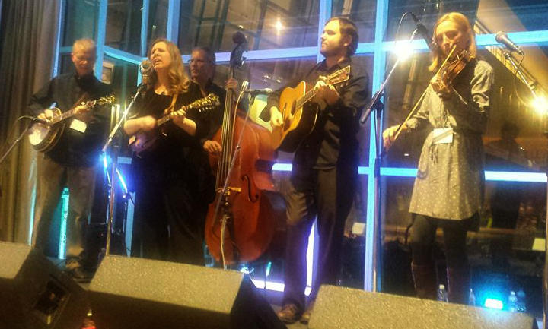
"Missy Werner is a bright light of Northern Kentucky whose music is kind on the ears and the soul." The Bluegrass Situation
Introducing Missy Werner. Born, raised, and a resident of the Cincinnati/Northern Kentucky area, Missy has carved a niche in the region as a respected vocalist and musician. In an era where many performers are frequently compared to others, she has developed a distinctive, easily recognizable voice. Whether performing a hard-hitting traditional song or a tender ballad, she makes the adjustment and delivers.
Missy formed her touring band after recording a 2009 solo project, "Drifting and Dreaming", one that gained her a large amount of national and worldwide attention. Her second release, “Three Kinds of Lonesome", also received excellent reviews from the industry and was on the list of most downloaded Bluegrass albums on AirPlay Direct in 2012 and was also #22 on The Roots Music Report Top Bluegrass albums of 2012. Her latest release, "Turn This Heart Around" featuring her band and well-respected industry colleagues and was released in 2014 with two singles making the Bluegrass Today Weekly Airplay chart. And, although only out for six months that year, the album managed to garner #23 on The Roots Music Report Top Bluegrass Albums of 2014.
She has been nominated twice for the IBMA (International Bluegrass Music Association) Female Vocalist of the Year, and locally nominated three times for a Cincinnati Entertainment Award in the Bluegrass Band category.
Her band is a group of veteran musicians that have developed tight trio and quartet harmonies designed to specifically compliment her voice and includes her husband of twenty-seven years, Artie Werner.
"Sung passionately with a power reminiscent of Union Station, Werner’s music takes the listener on an enjoyable journey that ranges from fast-paced bluegrass to emotive country ballads, with meticulously blended harmonies. And, by the way, Werner can really sing. Her pristine vocals are polished, tender, and emotive. Whether you like your bluegrass fast, slow, or someplace in-between, Werner’s music is likely to turn your heart around in short order and make you a fan." Stephen Ides, Bluegrass Unlimited
For more information, please visit www.missywerner.com

